***Online Bus Ticket Booking***

***Trainee Id : 1271516  
Name : Md.Ataur Rahman  
Batch: CS/PNTL-M/53/01***

***1. Activity diagram***: Activity diagrams in UML display the functionalities of various activities and flow in management processes and software systems. The flow in the activity diagram can be sequential, branched, or concurrent.

***2.Class Diagram***: Bus Booking System class Diagram describes the structure of a bus booking system classes, their attributes, operation (or method), and the relationships among objects. The main classes of the Bus Booking System are Bus, Booking, Customer, Sales, Ticket Booking, Operators***.***

***3.Use case Diagram:*** A UML use case diagram can create a broad, high-level view of the relationship between use cases, actors involved, and systems being performed.

***4.Sequence Diagram:*** A sequence diagram consists of a group of objects that are represented by lifelines and the messages that they exchange over time during the interaction. Sequence diagrams in UML are used to illustrate the sequence of messages between objects in an interaction.

***5.State Chart Diagram:*** The state machine diagram is also called the State chart or State Transition diagram, which shows the order of states underwent by an object within the system. It captures the software system's behavior. It models the behavior of a class, a subsystem, a package, and a complete system

***6.CRC Diagram:*** It is an error detection mechanism in which a special number is added to the block of data. The primary goal to add the number is to identify the changes during the transmission or storage. It is calculated twice, once at the sender side during the data transmission and recalculated at the receiver side. It compares data bit by bit with originally transmitted values.

Online Bus Ticket Booking system

Ticket Booking System is to manage the details of Shows, Booking, Payment, Customer. It manages all the information about Shows, Seats, Customer, Shows. The project is totally built at administrative end and thus only the administrator is guaranteed the access. The purpose of the project is to build an application program to reduce the manual work for managing the Shows, Booking,  
Seats, Payment. It tracks all the details about the Payment, Customer.

Case Study

This is collaborative project made to cater the needs of the passenger who are traveling from one point to another. This project have contains essential modules like Admin, User, Bus, Route, Reservation and Feedback. User can book / reserved his ticket one day before and give feedback about their experience

Activity Diagram

Activity Identified: Admin who is the main user in this application has the responsibility of adding buses, seat availability, bus fare, source, destination, etc. Online customers can browse or search items, view specific bus details, book them, view, add, and checkout. Users can view booking history at any time. Customers can make payments for the booking and view the payment history.

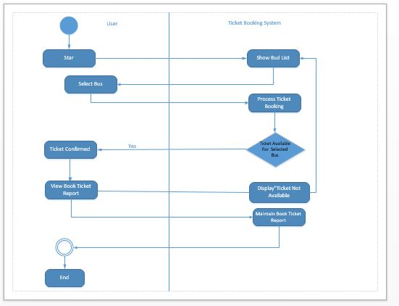

Class Diagram

Bus Booking System class Diagram describes the structure of a bus booking system classes, their attributes, operation(or method), and the relationships among objects. The main classes of the Bus Booking System are Bus, Booking, Customer, Sales, Ticket Booking, Operators.

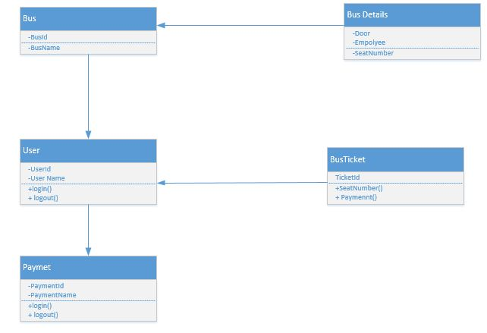

Use case diagram

From the below example, we can see that Admin will be able to add buses, view bus reports, and different buses and destinations of the bus into the system. Whereas, users can only view the bus list and access the system for ticket booking purposes.

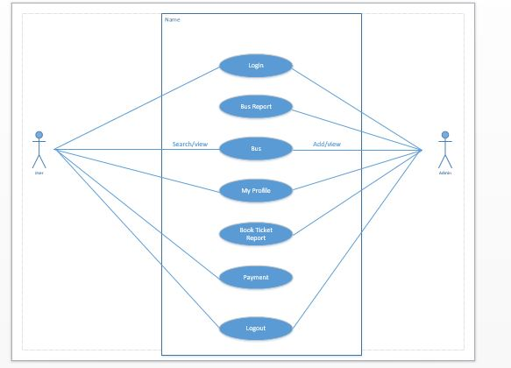

Sequence diagram

A user can register first using their name, contact number, and address and also can manage their profile. The user can log in to the system using their names& contact number. Users can search for buses and view if tickets are available for the same. Users can view/track their booked tickets, payment status, history, etc.

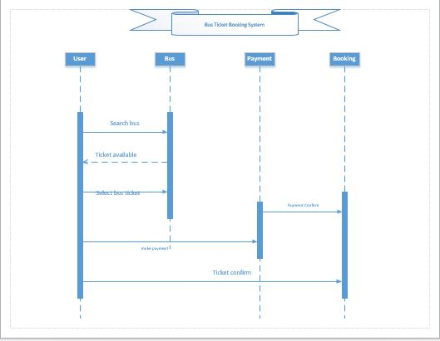

State Chart Diagram

The state machine diagram is also called the State chart or State Transition diagram, which shows the order of states underwent by an object within the system. It captures the software system's behavior. It models the behavior of a class, a subsystem, a package, and a complete system

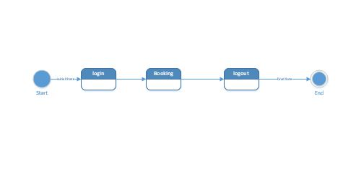

CRC Diagram

It is an error detection mechanism in which a special number is added to the block of data. The primary goal to add the number is to identify the changes during the transmission or storage. It is calculated twice, once at the sender side during the data transmission and recalculated at the receiver side. It compares data bit by bit with originally transmitted values.

